Croatia Adventure Itinerary
Oct 8 – 15th, 2016

Fasten your seatbelt and get ready for a week of adventure in Southern Dalmatia, Croatia. Here’s a close-up for you to preview some of the islands you’ll be seeing:

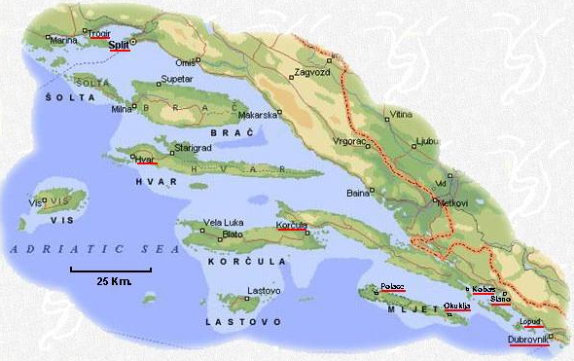

Croatia is an absolutely stunning part of the world. You’ll be experiencing historic islands, playing in unparalleled beauty and exploring classic harbor villages. We’ll also get to know the locals and taste our share of wine & food.

Now, let’s get started with the itinerary!

Croatia Adventure Itinerary
Oct 8 – 15th, 2016

Day 1: Sat, 8 October Trogir to Solta Island
We suggest arriving to Trogir early and exploring this lovely port town before we meet. Reminiscent of Venice, you’ll find yourself immersed in this beautiful port town. Your boat is in the harbor, so drop your bags and start exploring. After lunch, we’ll boat to Solta Island. Jump off the boat & get ready to ride past walled olive & fig groves on the way to our destination for the evening.
On the bike: 10-15 mile warm-up

Day 2: Sun, 9 October Solta to Hvar Island
This morning we head to island of Hvar, the sunniest island in the Adriatic. Once off the boat we’ll bike to the best gelato while seeing quaint, harbor towns. Then, we’ll ride to a picnic lunch and cruise past lavender fields and orange groves. We’re staying overnight in the town of Hvar, which has become a Mecca for artists — and the people who love them! On the bike: 15 – 40 miles

Day 3: Mon, 10 October Island of Vis
Vis has been a military zone for over 100years. Surprisingly, tourists were prohibited to visit Vis until 1995. It’s history & position from the mainland still keeps tourists away today. However, 2,300 years ago the Greek colony of Issa was flourishing here. We’ll use bike for transportation & enjoy the quiet surroundings.
Lunch at a local vineyard. Sleep at the Vis harbor.
On the Bike: 30 miles hilly

We reserve the right to make changes to the itinerary
Croatia Adventure Itinerary
Oct 1- 8th, 2016

Day 4: Tues, 11 October Korcula Island
Korcula and its cypress gardens is considered to be the most beautiful of the Dalmatian Islands. After sailing from Vis we’ll ride to Blato which, like Rome, is built on seven hills. After a coffee break, we’ll ride over to the other side of the island. The ride finishes in Korcula, the birthplace of Marco Polo. Off the bike, we’ll tour the city & see what it means to eat like a local! On the bike: 35+ miles

Day 5: Wed, 12 October Islands of Hvar and Brac
Today we’re back to the southern point of Hvar Island where we have a fantastic morning bike ride from Sucuraj to the beautiful Bay
of Pokrivenik. Enjoy a swim, check out local shops and dive into lunch, before we head to the island of Brac. and the town of Pucisca. We’ll dock in the harbor of Pucisca and find out why all the white marble of the White House comes from here. Dinner on the boat! On the bike: 20 miles or more

Day 6: Thur, 13 Oct Cetina Canyon Bike & Raft
Wake up, eat breakfast and get ready to bike in the valley of the Cetina River. This gorgeous canyon is surrounded by steep, cliff walls. After cruising down quiet side roads, past pirate castles, you have an option: Ride back to town or trade your saddle for a 3hr river raft down the Cetina River. After lunch, we’ll hop back on the boat and head to the village of Split. Our local guides will take you on a walking tour of this exciting village.
On the bike: 15, 30 or 50 miles

*We reserve the right to make changes to the itinerary*
Croatia Adventure Itinerary
Oct 1- 8th, 2016

Day 7: Fri, 14 Oct Split and Trogir
Wake up early and bike ride through Marjan Park, considered the lungs of Split. Post-ride, check out the palace of a Roman Emperor and a UNESCO World Heritage site. After lunch we will anchor for a couple of hours for those who might wish to swim or just relax before we head back to Trogir late afternoon. On the bike: 10 miles, plus

Day 8: Sat, 15 Oct Trogir & Departure
Enjoy our final breakfast and fresh bread. Although all rooms must be cleared by 9am, feel free to leave your luggage, tour the town and enjoy the last day to the fullest. For those flying out of Split, we wish you safe travels. We appreciate you joining us!

*We reserve the right to make changes to the itinerary*

