MYSTICAL MOROCCO
Dec 25 – Jan 4, 2018

Day 1 26 Dec WELCOME TO MOROCCO!

VIBE: Welcome to Fes! After a quick 20min transfer you’ll be at the hotel. Unpack your bags for 3 glorious nights & check out your cool riad.

EAT: Cocktails + Traditional Moroccan Dinner at our riad

SNOOZE: Fes, Morocco http://riadfesmaya.com or similar

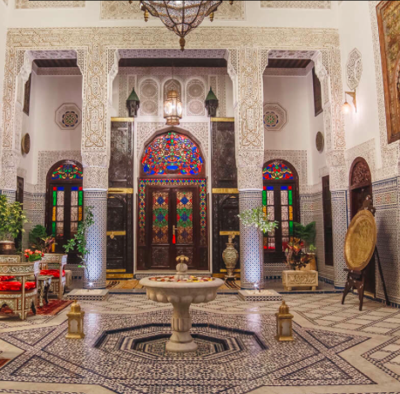

MYSTICAL MOROCCO
Dec 25 – Jan 4, 2018

Day 2 27 Dec MINT. SPICES. MEDINA.

VIBE: Wake up to French mint tea and a delicious breakfast. Our private guide is taking us deep into the labyrinth of the Fes-el-Bali medina. We’ll shop, learn & see the incredible, 1000yr old tannery. There are no cars allowed today but you will need to watch out for donkey carts.

EAT: Street Food. Local Food. Moroccan Food.

SNOOZE: Fes, Morocco http://riadfesmaya.com or similar

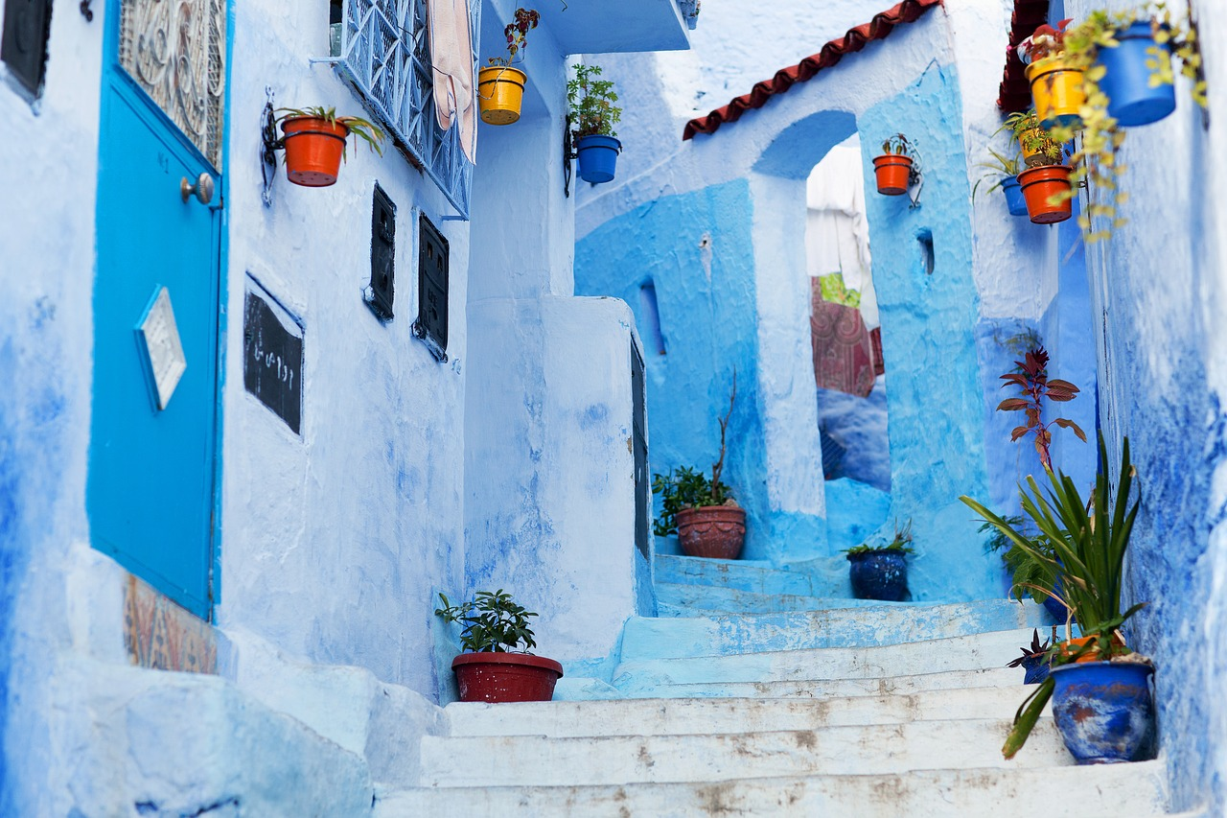

Day 3 28 Dec CHEFCHAOUEN – BLUE CITY

VIBE: Today is our Fes Free Day! What’s that? Feel free to stroll the medina and shop, join a cooking class, get a massage or take a bus to Chefchaouen, the Blue City.

EAT: Group Dinner + Show & Tell

SNOOZE: Fes riad

MYSTICAL MOROCCO
Dec 25 – Jan 4, 2018

Day 4 29 Dec FLYING INTO THE DESERT

VIBE: After a leisurely breakfast, we’ll pack our bags and head to Rabat, the capital of Morocco. This bustling city is on the Atlantic Ocean & full of life. In the evening, fasten your seatbelts we’re flying from Casablanca to the Sahara desert!

EAT: Food on the fly! Simple dinner in fun location

SNOOZE: Gites Palmeraie http://www.danslapalmeraie.com

FUN FACT: Gites Palmeraie is a rarity. It’s located in a desert oasis and is owned by a Morocan family. The accommodations are simple but full of love & kindness.

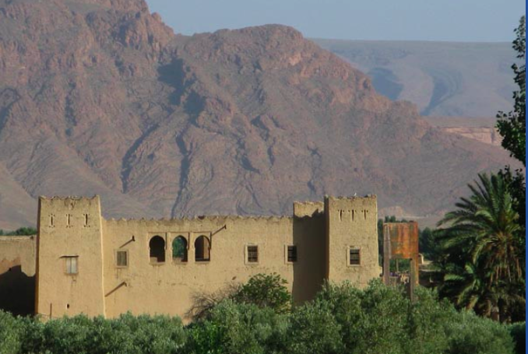

MYSTICAL MOROCCO
Dec 25 – Jan 4, 2018

Day 5 30 Dec A REAL DESERT OASIS

VIBE: Get ready to meet the locals, dine in ksar and learn about the countryside culture. We’re traveling on a different mode of transportation and learning how to dance like a Bedouin.

EAT: Learn the art of coucous with local women.

SNOOZE: Gites Palmaire http://www.danslapalmeraie.com

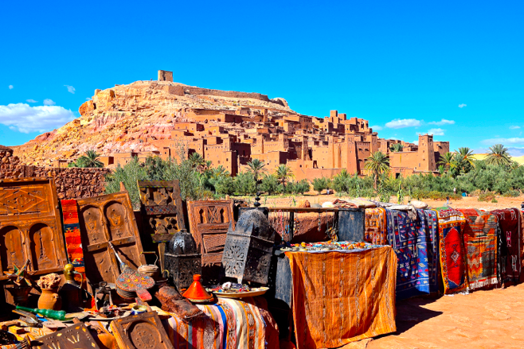

FUN FACT: This day has been arranged by the owner & manager of our “gites”. They’d like to introduce to local families and teach us about their culture.
MYSTICAL MOROCCO
Dec 25 – Jan 4, 2018

Day 6 31 Dec NEW YEARS EVE CELEBRATION!

VIBE: This morning we’re getting intimate with artisans & finding fossils. We’ll visit a souk ksar and head into the heart of the desert. We’ve got a big day planned so get ready to play!

EAT: New Years Eve Moroccan Feast. Music. Dance. Celebrate!

SNOOZE: Sahara Desert Glamping

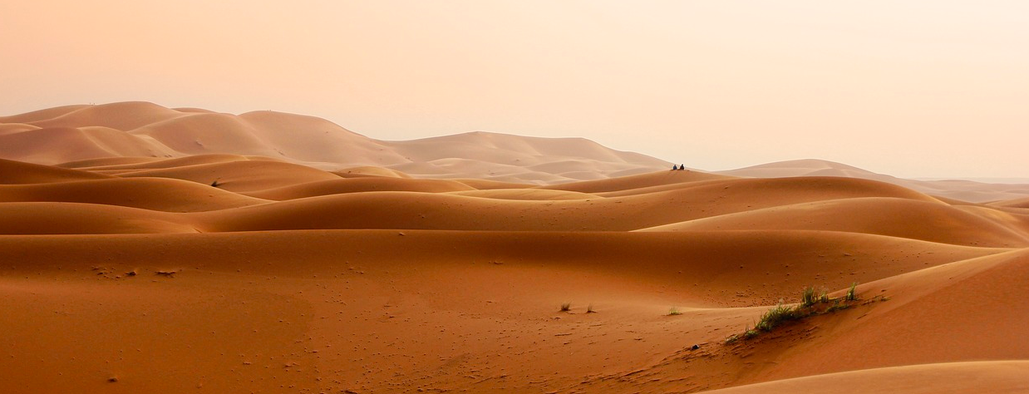

Day 7 1 Jan THE SPIRITUAL SAHARA

VIBE Party until the sun comes up and our beatufiul Bedouin hosts will take us to see a stunning sunrise. We’ll tour the dunes via camels or 4x4’s

EAT: Lunch with a nomadic family. Traditional Berber dinner at our ecolodge. Fresh veggies from the garden.

SNOOZE: Dar Lorkam http://www.skoura.com.fr/eng/index.php

FUN FACT: Our private, ecolodge is located in a rare grove of 30,000 palm trees.
MYSTICAL MOROCCO
Dec 25 – Jan 4, 2018

Day 8 2 Jan DESERT TO CITY

VIBE: After breakfast, we’re headed to Marrakech. The afternoon will be a private city tour with a local.

EAT: Moroccan Wines + Private Dinner at our Dar

SNOOZE: http://www.darlallafdila.com

FUN FACT: Dar l’alla fdila was once the entertainment home of a sultan. It was also a secret hideaway of actress Josephine Baker.

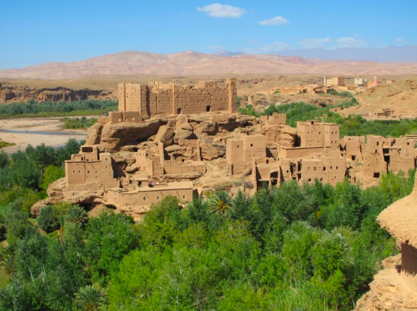

Day 9 3 Jan MAGICAL MARRAKECH

VIBE: Experience the incredible souks and markets of Marrakech. Shop for spices, rugs, lamps and even uncover a snake charmer. In the afternoon take time to relax & enjoy a hammam.

EAT: Cocktails + Group Dinner

SNOOZE: http://www.darlallafdila.com

MYSTICAL MOROCCO
Dec 25 – Jan 4, 2018

Day 10 4 Jan MOROCCO to USA

VIBE: Savor a cup of fresh mint tea, handmade pastries and fresh fruit before transferring to the airport. For anyone departing in the afternoon we’ll head out to do some food tasting.

EAT: Breakfast at our private dar

SNOOZE: Grab your blankie and get cozy up in the sky

