UNCOVER UKRAINE:
FOOD & CULTURE

Day 1 WELCOME TO UKRAINE

DO: Arrive to Kyiv. Transfer to the hotel. Leave your luggage and get familiar with the capital strolling by the main street – Khreshchatyk.

EAT: Get acquainted with Ukrainian cuisine, enjoying dishes and live folk music

SLEEP: Kyiv

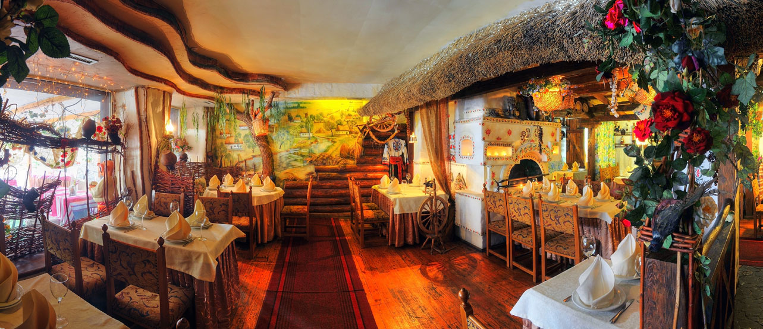

UNCOVER UKRAINE:
FOOD & CULTURE

Day 2 EXPLORE the CAPITAL of Kievan Rus'

DO: Kyiv walking tour. Did you know that Kyiv was the capital of very powerful and prosperous state named the Kievan Rus? Today we’ll explore Kyiv from ancient times to the present.

EAT: Try all that Ukrainian cuisine has to offer.

EXPLORE: Discover Ukrainian traditional and modern art, walk, and taste, feel the city.

SLEEP: Kyiv

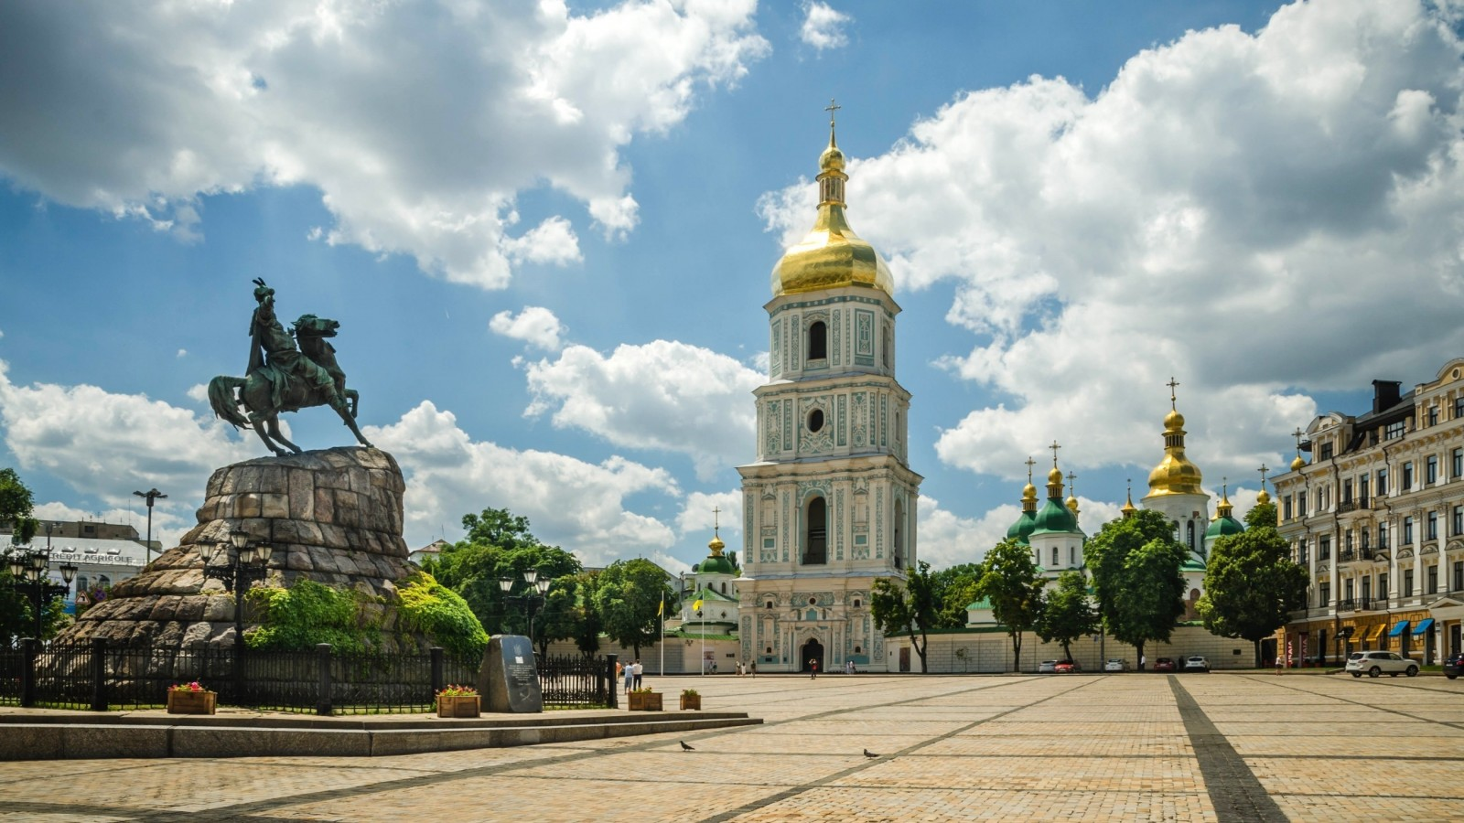
UNCOVER UKRAINE:
FOOD & CULTURE

DAY 3 LEARN ETHNIC CRAFTS

DO: How long ago have you made something for home with your own hands? Spend the day as Ukrainians did hundreds of years ago. You will learn pottery, make a traditional doll that will guard your home, and prepare a Cossack kulish for the lunch.

EAT: Traditional Cossack lunch

SLEEP: Kyiv

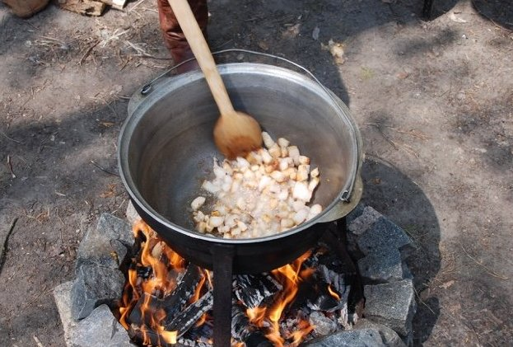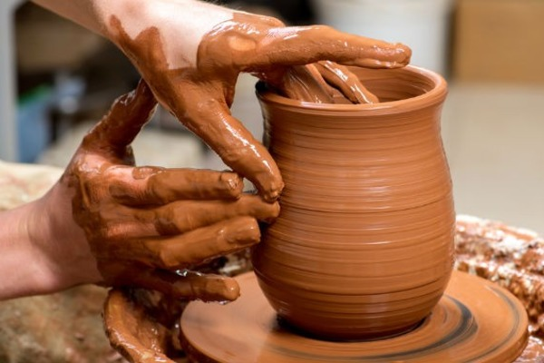
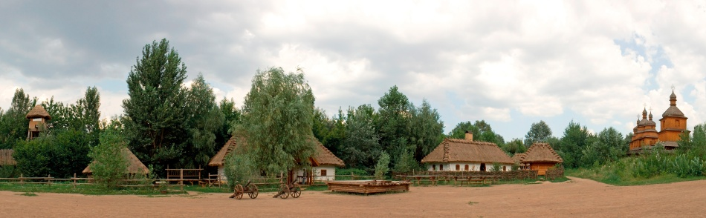

UNCOVER UKRAINE:
FOOD & CULTURE

DAY 4 FLY to the HEART of UKRAINE

TRANSFER: Fly to Ivano-Frankivsk. Transfer to the picturesque area – Carpathian Mountains (2.5hrs).

LUNCH: We’ll enjoy the lunch time in favorite locals’ place in Ivano-Frankivsk.

DO: Breath in deeply – you’re in the best place to connect with the nature.

SLEEP: Private house in the mountains.

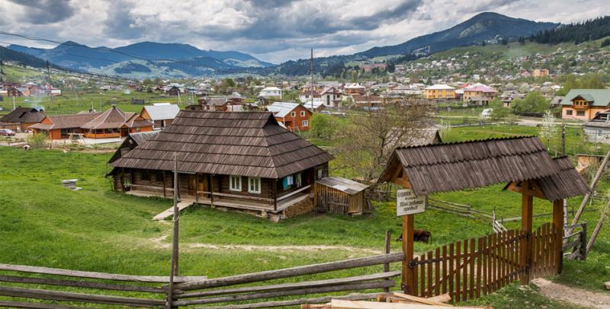

UNCOVER UKRAINE:
FOOD & CULTURE

DAY 5 SPEND DAY LIKE A HUTSUL

DO: Hike the mountains and meet locals who still live like hundreds of years ago. Meet a cheese maker and taste local products. Learn how to play the longest woodwind instrument of trembita.

EAT: A picnic on the meadows.

SLEEP: Private stay in a country house.

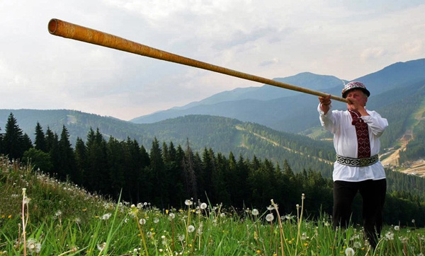

UNCOVER UKRAINE:
FOOD & CULTURE

DAY 6 RELAX and ENJOY

DO: Meet Ukrainian lady who’ll teach you how to cook a festive meal of varenyky. Could you believe that one dish can be served as a main course and the dessert at the same time?

After lunch meet the locals who do handcrafts and visit Ukrainian spa.

EAT: Enjoy what you cooked

SLEEP: Private stay in a country house.

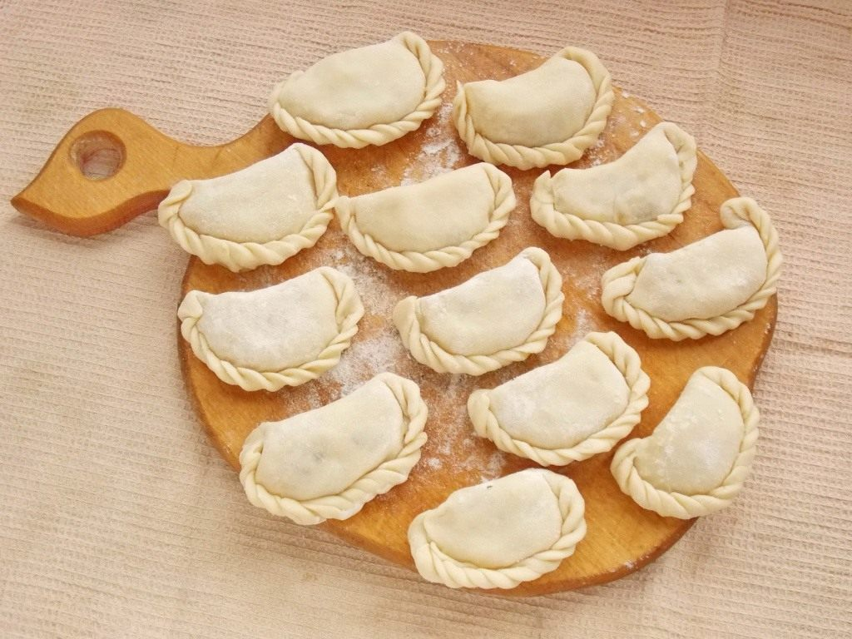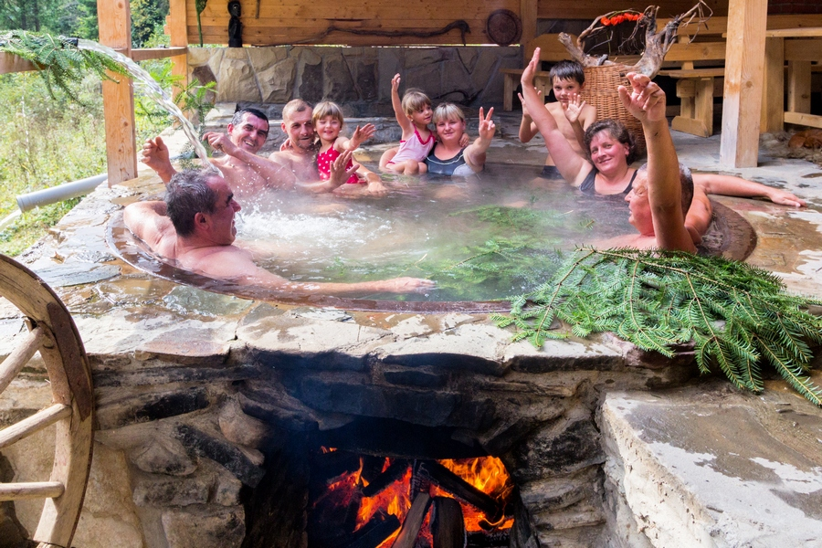

UNCOVER UKRAINE:
FOOD & CULTURE

DAY 7 From MOUNTAINS to LITTLE PARIS

DO: Visit a local market in the mountains.

Drive to Lviv – Ukrainian cultural capital (4.5hrs)

SLEEP: Boutique hotel in the city center

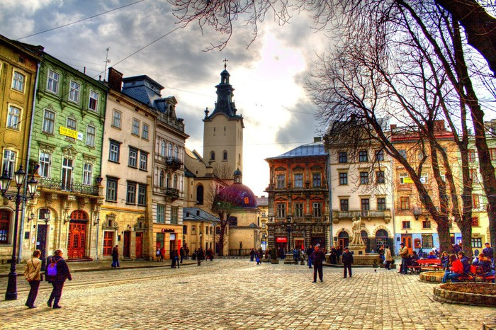

UNCOVER UKRAINE:
FOOD & CULTURE

DAY 8 EXPLORE LVIV

DO: Lviv food & legends tour. This city is full of legends and mysteries that can be unraveled only after exploring its undergrounds, roofs and secret places. It’s not a usual tour; it’s a real quest around the city.
Free time in this lovely city.

EAT: Authentic lunch at the knaipa (a secret place that can be reached only if you know a password – you’ll know it after the tour)

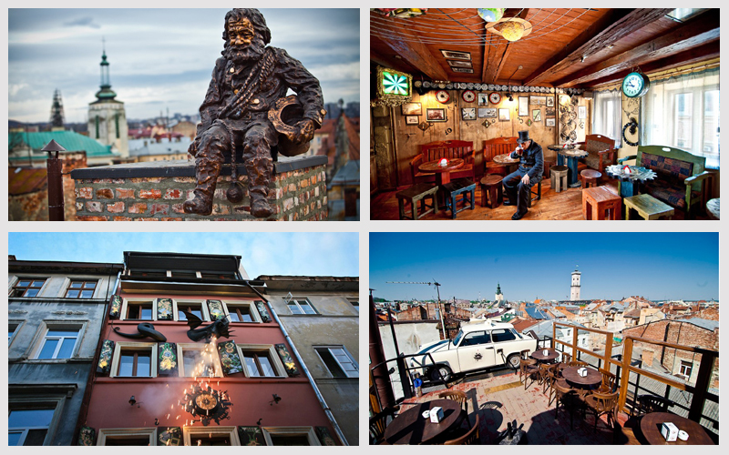

UNCOVER UKRAINE:
FOOD & CULTURE

DAY 9 «DO POBACHENNYA» - DEPARTURE DAY

Thank you for exploring Ukraine with us.
We wish you smooth travels!

